PV panel simulation in TRNSY & PVsyst
  - Arshia Dinmohammadi-810601219
  - October 26, 2025

Introduction
Solar photovoltaic (PV) panels are devices that convert sunlight directly into electricity through the photovoltaic effect. They are made of semiconductor materials, most commonly silicon, that absorb solar radiation and generate electric current when exposed to sunlight. PV panels can be installed on rooftops, open fields, or integrated into building structures to supply clean and renewable electricity. They operate silently, require minimal maintenance, and have a long lifespan, typically exceeding 25 years. As global energy demand continues to rise, PV technology has become a key solution for reducing dependence on fossil fuels and mitigating greenhouse gas emissions.
The use of solar panels extends across residential, commercial, and industrial applications. In homes, PV systems can power appliances and lighting or work in combination with battery storage for off-grid use. In commercial buildings, solar energy reduces operational costs and carbon footprints, while in large-scale solar farms, it contributes to national grids and supports energy transition strategies. Solar panels are also employed in remote or rural areas where conventional electricity access is limited, powering water pumps, telecommunications systems, and even electric vehicle charging stations. Their versatility, sustainability, and declining installation costs make PV panels one of the most promising technologies for a cleaner energy future. [1]
The main goal of this project is to analyze and simulate the performance of photovoltaic (PV) solar panels using TRNSYS and PVsyst software to better understand their behavior under real environmental conditions and design constraints. Through this assignment, students are expected to model the VSUN450-144BMH solar panel, plot I–V characteristics at different irradiance levels, and evaluate annual variations in solar radiation, temperature, and PV power generation for Tehran. Additionally, the project aims to determine the maximum number of PV panels that can be installed on a given rooftop while avoiding shading losses by calculating appropriate spacing between panel rows. Overall, the objective is to combine theoretical knowledge and practical simulation skills to optimize PV system design and assess solar energy potential in a specific location.

System description
A photovoltaic (PV) solar system works by converting sunlight directly into electricity through the photovoltaic effect, a process that occurs in semiconductor materials such as silicon. When sunlight hits the surface of a PV cell, photons from the light excite electrons within the semiconductor material, causing them to move and create an electric current. Each PV cell produces a small amount of direct current (DC) electricity, and many cells are connected together to form a solar panel. Multiple panels can then be connected in series or parallel to create a PV array capable of generating higher power levels suitable for residential, commercial, or industrial use.
The generated DC electricity is typically passed through an inverter, which converts it into alternating current (AC) electricity that can be used by household appliances or fed into the power grid. The performance of the PV system depends on several factors, including solar radiation intensity, panel temperature, tilt angle, and orientation toward the sun. In this project, software tools such as TRNSYS simulate how these parameters vary throughout the year and affect energy output, while PVsyst helps design the optimal layout of panels to minimize shading and maximize efficiency. Together, they provide a complete understanding of how solar panels operate and how their design and placement influence overall system performance. [2]
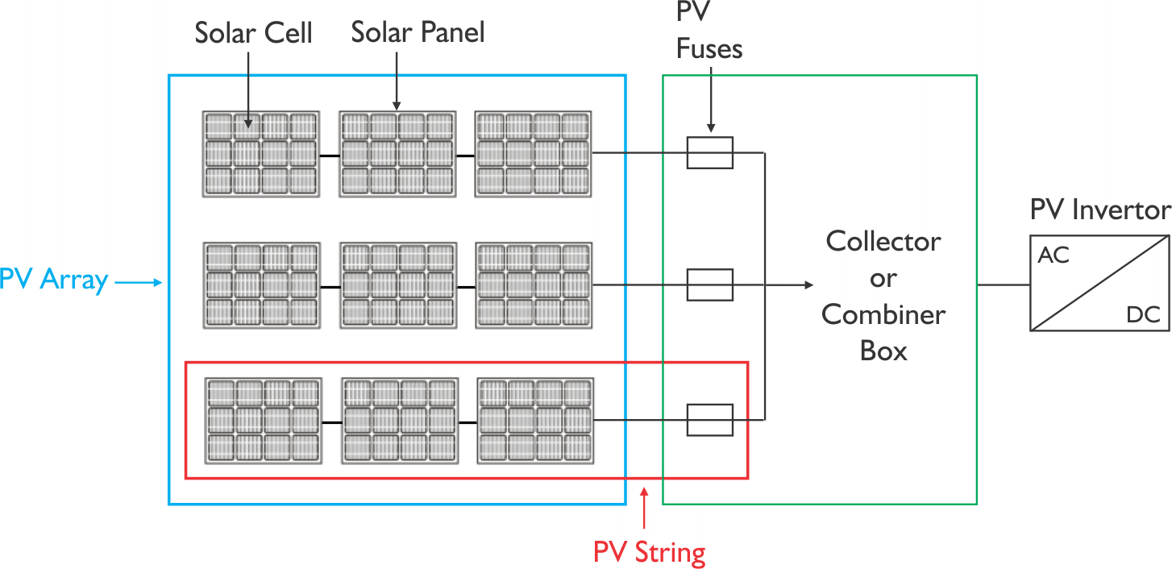
Figure 1. The schematic of a PV Array. [3]

Modeling

TRNSYS software

Part a)
In this section, the objective is to plot the current–voltage (I–V) characteristics of the photovoltaic (PV) panel using TRNSYS software and to validate the simulated results by comparing them with the manufacturer’s catalogue data under three different irradiance conditions: 1000 W/m², 800 W/m², and 600 W/m².
At the initial stage of the simulation, it is necessary to apply a range of input voltages to the photovoltaic panels in order to obtain the corresponding output current values. To achieve this, a new equation is inserted from the “Assembly” section within the workspace. As illustrated in Figure 2, the output variable V is defined as a function of time in the equation editor. The simulation parameters, shown in Figure 3, specify a stop time of 60 hours and a time step of 0.01 hours to ensure adequate temporal resolution.
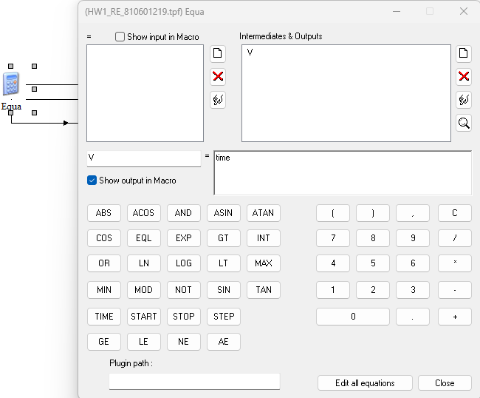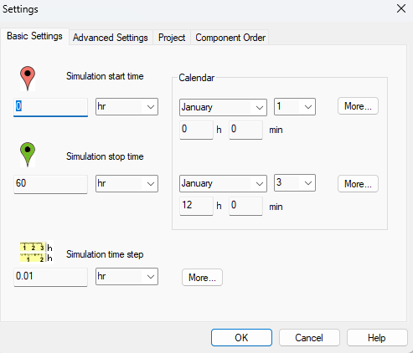
Figure 2. equation settings. Figure 3. Settings.

Subsequently, a basic photovoltaic (PV) panel without MPPT control is inserted from the “Electrical” folder located in the right-hand panel of the TRNSYS workspace. The panel parameters are then configured using the catalogue data for the VSUN450-144BMH module, as illustrated in Figure 4. Following this, the equation calculator is connected to the PV panel, linking the output variable V to the input “Load Voltage,” as shown in Figure 5. Finally, the beam radiation parameter is set to the desired values, and the simulation is performed for three different irradiance conditions—1000 W/m², 800 W/m², and 600 W/m²—in accordance with Figure 6.
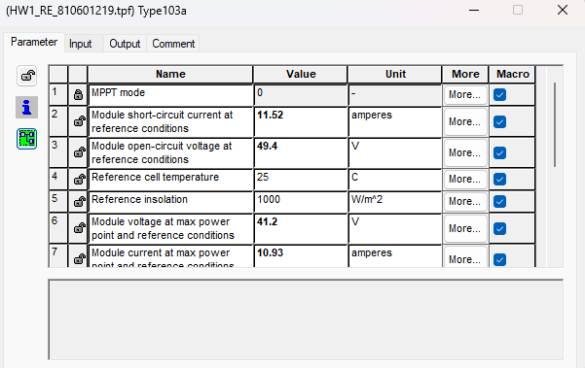
Figure 4. Parameter menu of PV panel.
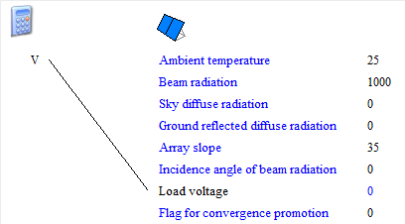
Figure 5. connection area of the lines.
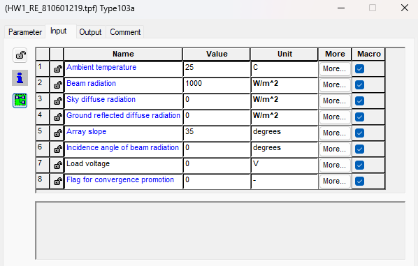
Figure 6. example for inputs of PV panel.
Subsequently, a no unit online plotter is added from the “Output” folder to visualize the simulation results. The PV panels are connected to the plotter as illustrated in Figure 7. Subsequently, the output variable “array current” is assigned to one of the left axes, while the “array power” output is linked to the corresponding right axis, as shown in Figure 8. This configuration enables the simultaneous monitoring and comparison of current and power variations during the simulation process.
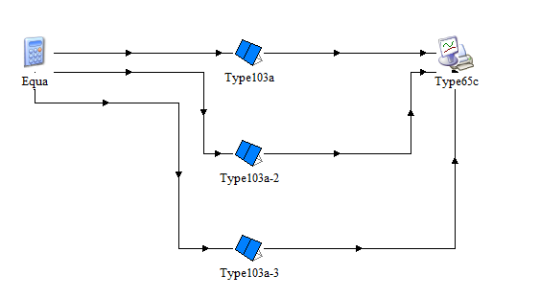
Figure 7. The last step of connecting.
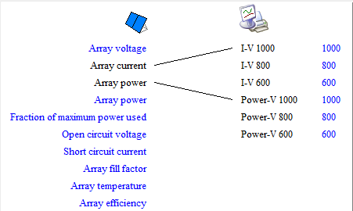
Figure 8. linking PV panels and plotter.
In the final step, the plotter parameters are configured by setting the maximum value of the left axis to 12 and the maximum value of the right axis to 500. The corresponding units are then defined within the “Special Cards” section, as shown in Figure 9. Once these settings are applied, the simulation is executed, and the results are generated for analysis.
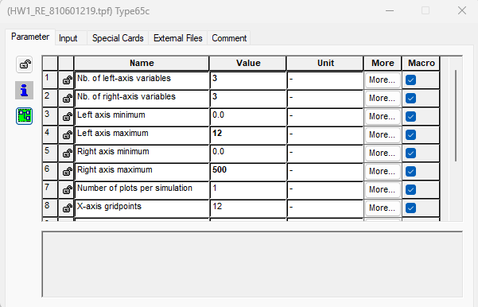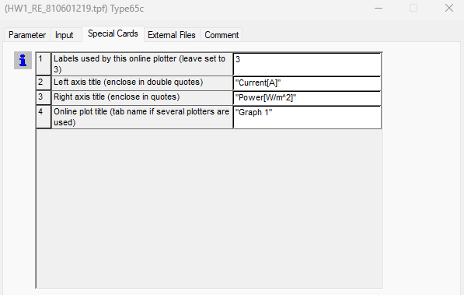
Figure 9. Plotter settings.
The final simulation results are presented in Plot 1. When compared with the manufacturer’s catalogue data, slight discrepancies are observed; however, the deviations fall within an acceptable error range, indicating that the simulation accurately represents the panel’s performance.
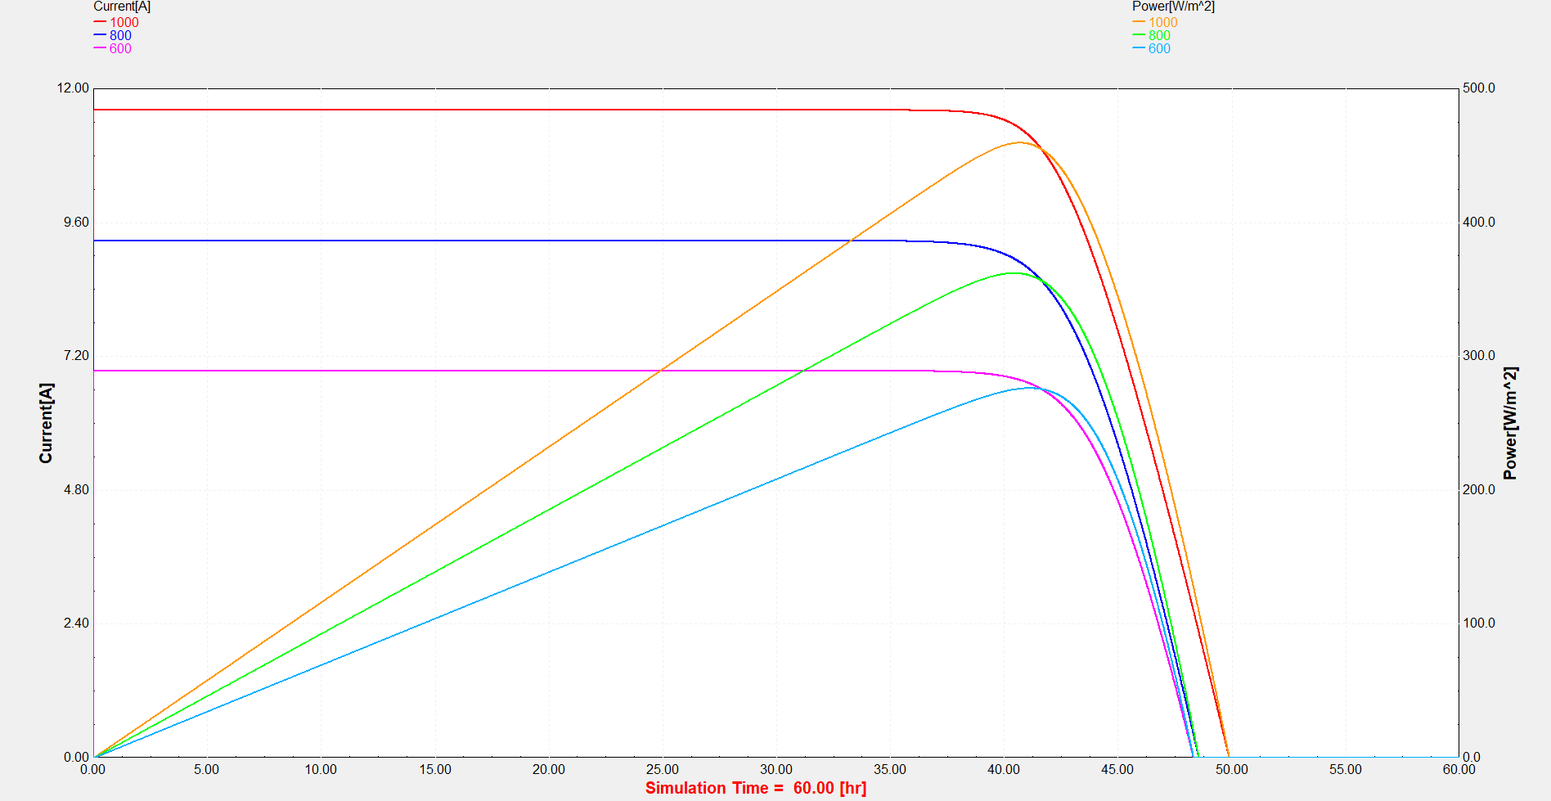
Plot 1. I-V curves and Power-Voltage curves

Part b)
In this section, the aim is to analyze and visualize the annual variations of solar radiation, ambient temperature, and photovoltaic (PV) power output, as well as to compute and present the monthly average power generation of the PV system.
Initially, the weather data for Tehran are imported by inserting a TMY2 component from the “Weather Data” section located in the right-hand panel. A TM2-format file is generated using the Meteonorm software and subsequently linked to the TMY2 component to enable the simulation to read the corresponding climatic data, as illustrated in Figure 10.
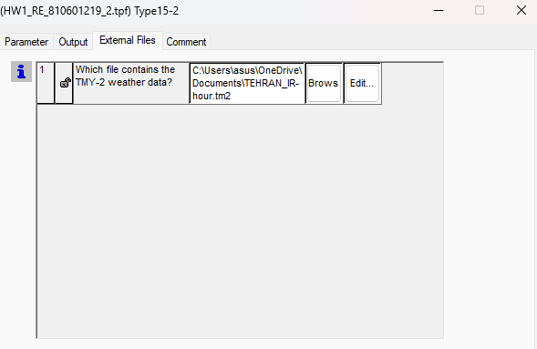
Figure 10. TMY2 external file settings.
Subsequently, to plot the solar radiation, it is necessary to utilize the total tilted radiation incident on the surface. Since the output unit of the TMY2 component is given in kJ/(hr·m²), a conversion to W/m² is required. This is achieved by introducing an equation component, where the total tilted radiation is connected to the equation input, and the equation output is linked to an online plotter, as illustrated in Figure 11. The resulting plot is presented in Plot 2.
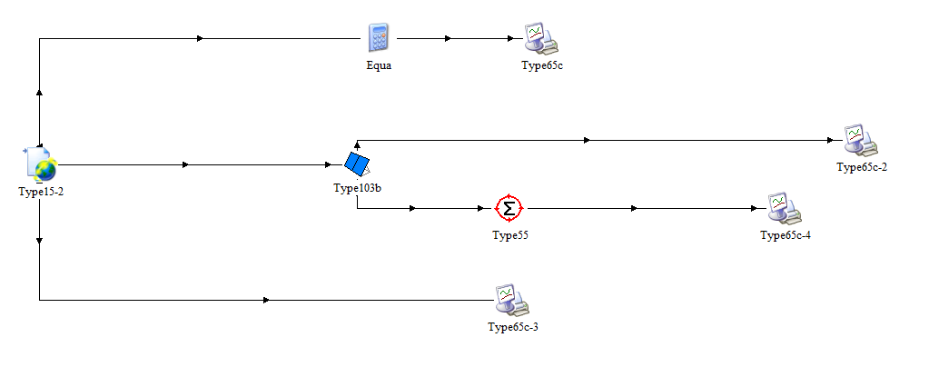
Figure 11. TRNSYS system’s connections.
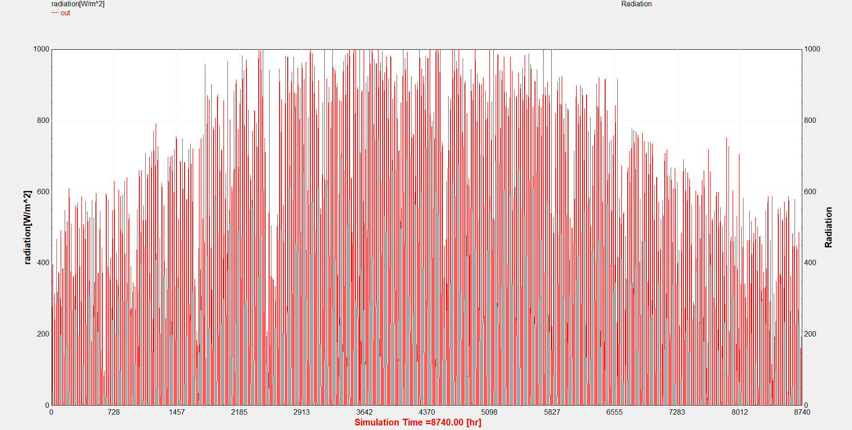
Plot 2. Radiation of Tehran during year.
For the temperature analysis, the dry-bulb temperature data extracted from the TMY2 component are directly connected to an online plotter, as illustrated in Figure 11, to depict their temporal variation over the simulation period. The resulting temperature profile is presented in Plot 3.
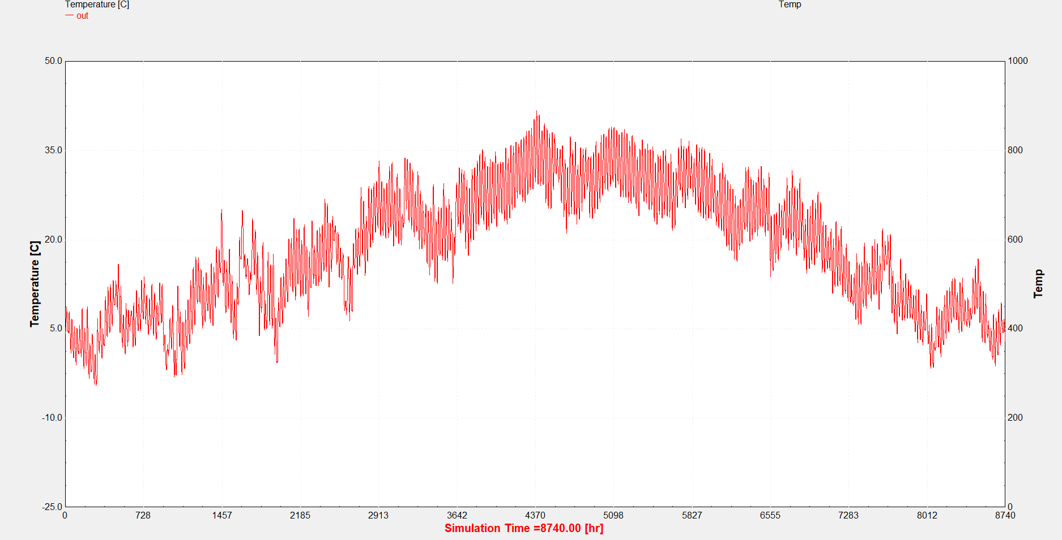
Plot 3. Dry bulb temperature of Tehran during a year.
To calculate the annual power generation, the TMY2 component is connected to a basic PV panel in MPPT mode, with the input configuration arranged as shown in Figure 12. The panel parameters are defined based on the catalogue specifications of the VSUN450-144BMH module. Subsequently, the array power output from the PV panel is linked to an online plotter to visualize the system’s power generation over the year. The resulting output is presented in Plot 4.
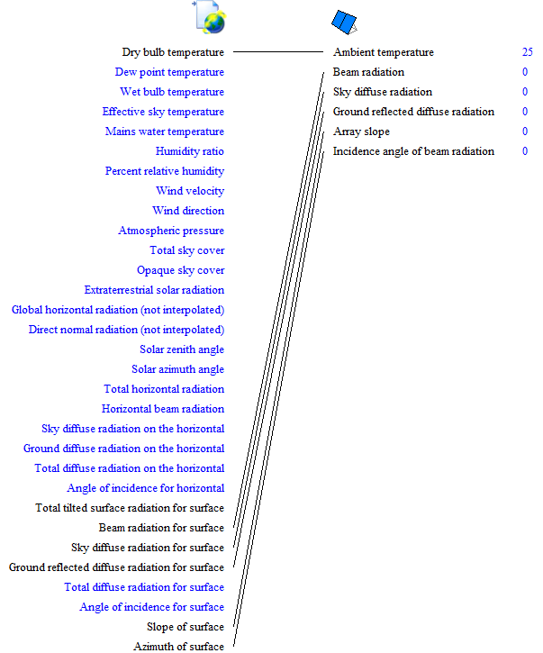
Figure 12. linking Tehran annual weather data to PV panel.
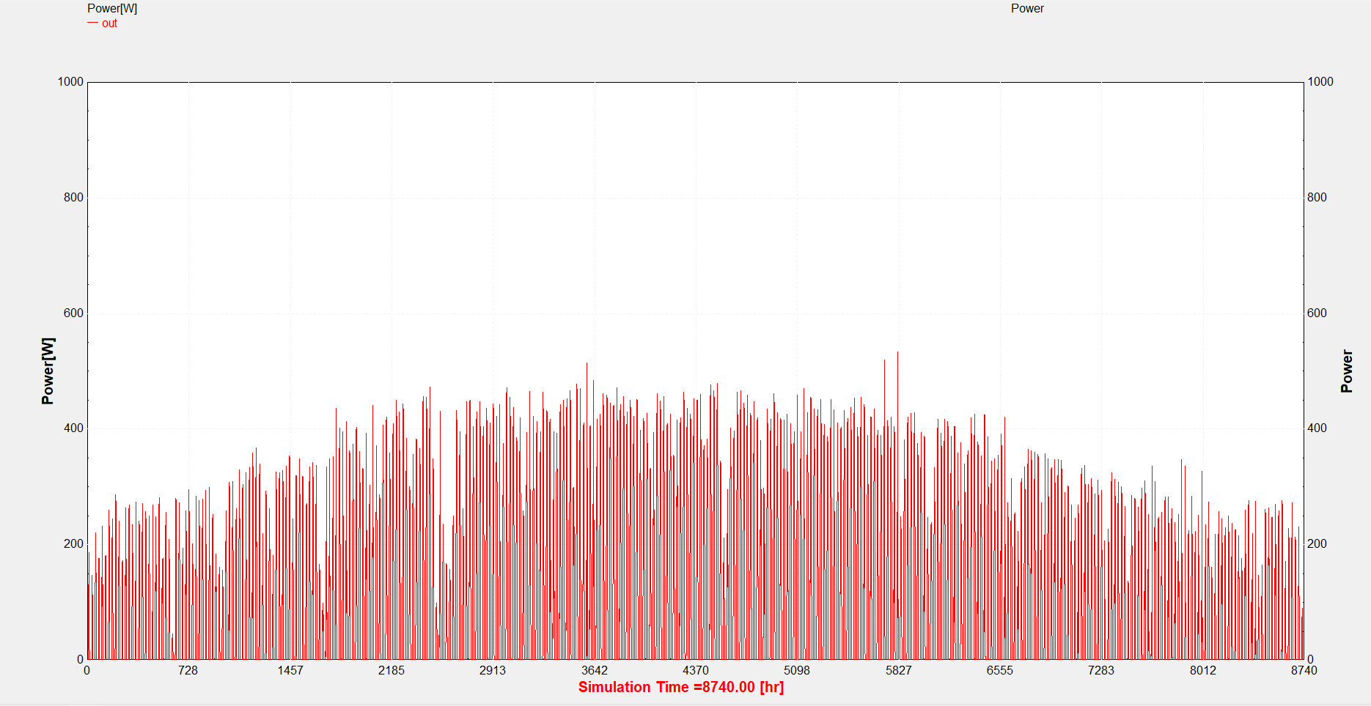
Plot 4. PV panel annual power generation in Tehran.
Finally, to determine the monthly average power generation, the PV panel output is connected to an integrator component, configured as illustrated in Figure 13. The integrator output is then linked to an online plotter to display the resulting data. The corresponding monthly average power profile is presented in Plot 5.
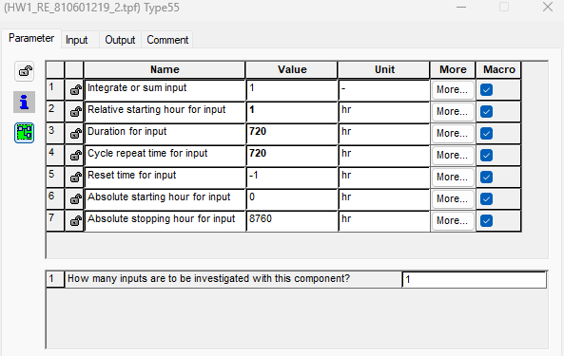
Figure 13. Integrator configuration.

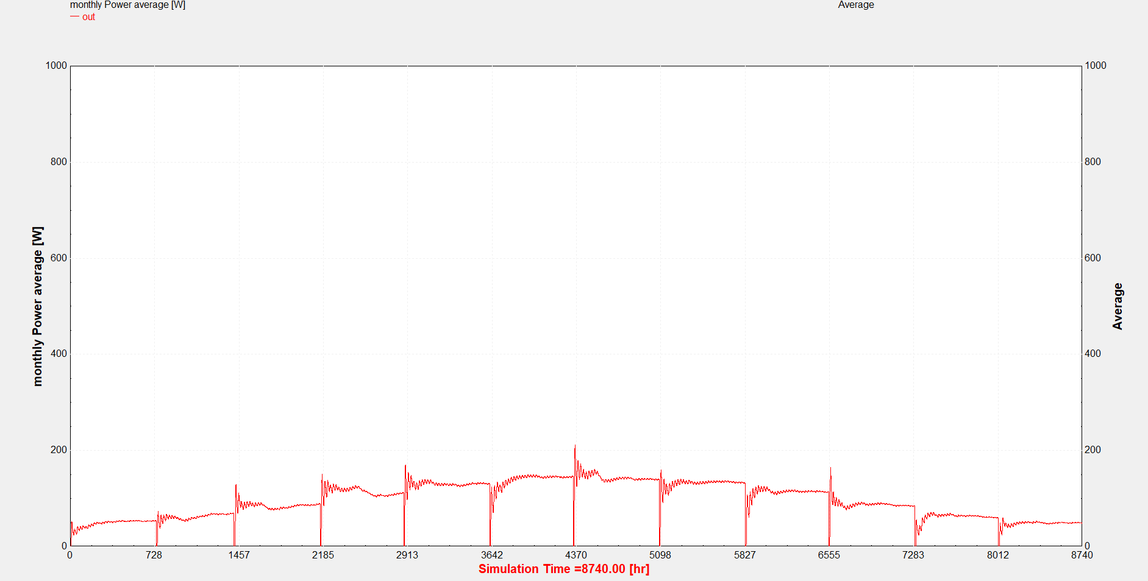
Plot 5. Monthly average of power generation during a year.

PVsyst software

Part c)
In this section, the objective is to determine the maximum allowable number of photovoltaic (PV) panels that can be installed on the rooftop using the given formula (Equation 1), evaluated under the worst-case scenario—at 3:00 p.m. on December 21, when shadow lengths are at their maximum.

$$D_{min}=\frac{L*\sin{β}*\cos{γ}}{\tan{α}} (equation 1.)$$
In which β is tilt angle of panel, α is solar elevation angle and γ is azimuth angle.
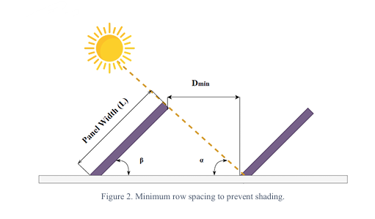
Figure 14. Schematic of sunlight incident on a solar panel
The required angles for the calculation were determined using the 3D Sun Path tool, as illustrated in Figure 15.
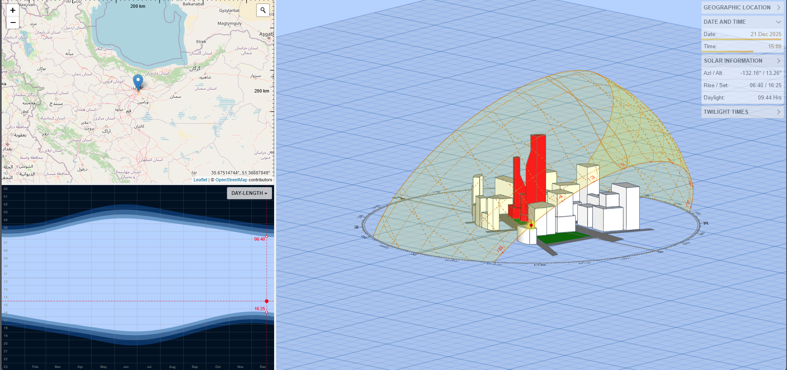
Figure 15. 3d-sun path of Tehran at 3:00 p.m. on 21 December. [4]
Now putting the angles in the formula using dimension given in the catalogue (L=1.048m)
$$α=13.26° \& β=35°=47.84° \& γ=180°-132.16°=47.84°$$
$$\underset{⇒}{ horizontal } D_{min}=\frac{1.048*\sin{35°}*\cos{47.84°}}{\tan{13.26°}}=1.712 m$$
Thus, in addition to the margin distance and the length of the PV panels, we have the following:
$\underset{⇒}{horizontal panel}D=1.712+L*\cos{35°}=2.571 m$
Between each panel in y-direction and dimension of the roof reduced to:
$$12-0.6=11.4 m \& 10-0.6=9.4 m \& 14.5-0.6=13.9 m \& 4-0.6=3.4 m$$

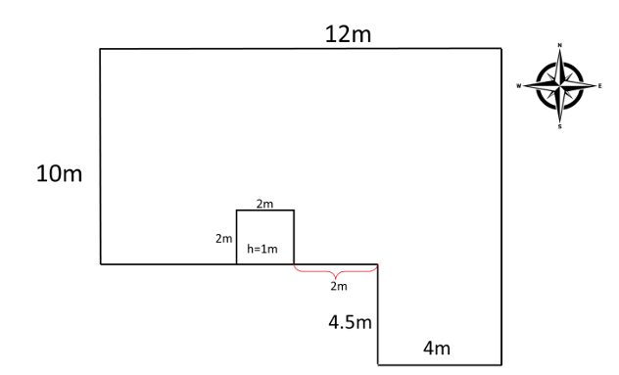
Figure 16. roof top map.
Based on the calculations and using SolidWorks to generate a layout, the maximum horizontal arrangement of PV panels on this rooftop, as shown in Figure 17, accommodates 14 panels.
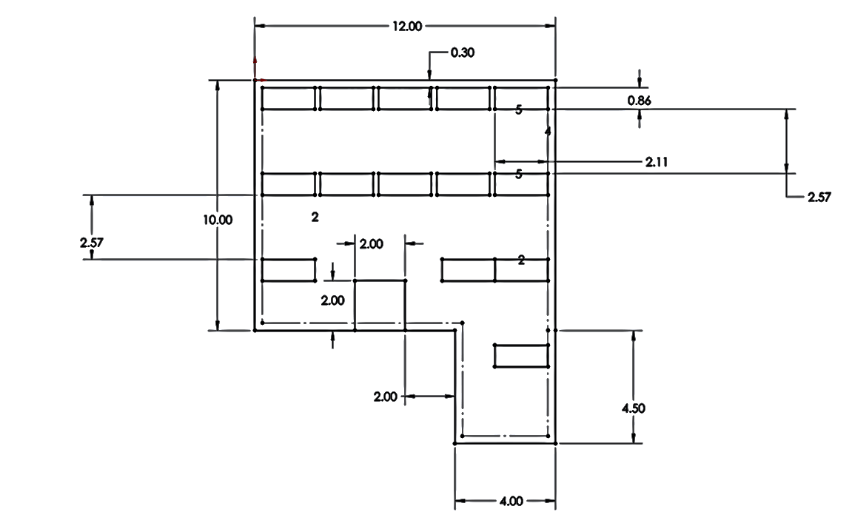
Figure 17. horizontal panels map.
Applying the same method for vertical panel placement increases the maximum capacity to 17 panels, as shown in Figure 18.
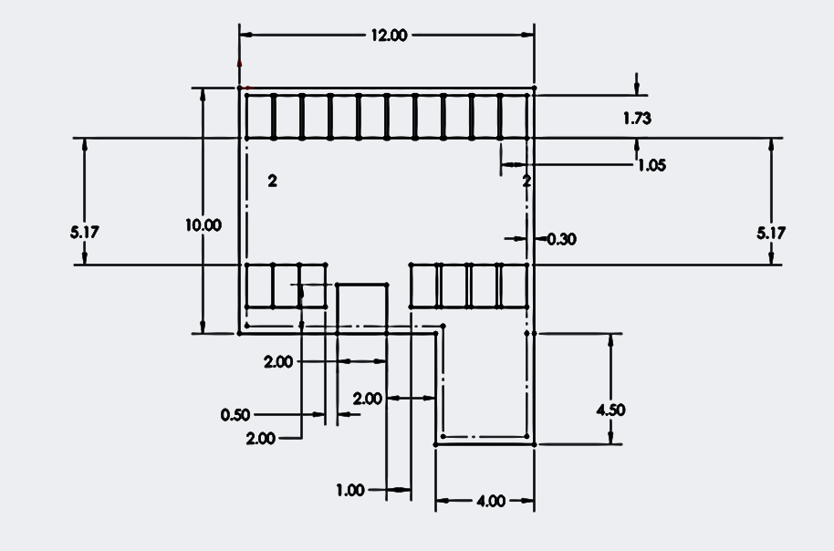
Figure 18. vertical panels map.

Part d)
In this section, PVsyst software is utilized to determine the optimal orientation of the photovoltaic panels and to estimate the maximum number of panels that can be installed to achieve the best overall performance. Several scenarios are analyzed and compared to identify the configuration that provides the most efficient energy output.
In this study, the VSUN-450-144-MH photovoltaic module is employed within PVsyst, and the inverter configuration is varied in each scenario to evaluate the impact on system performance.
Scenario 1)
In this scenario, six inverters are utilized, each incorporating an independent Maximum Power Point Tracking (MPPT) unit through the multi-MPPT configuration. Each inverter is rated at 3 kW, as presented in Figure 19. The system employs vertically oriented photovoltaic panels, arranged in packs of three modules installed with the minimum permissible spacing and a marginal distance of 50 cm between adjacent panel groups, as illustrated in Figure 20.
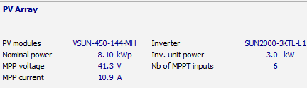
Figure 19. PV array parameters.
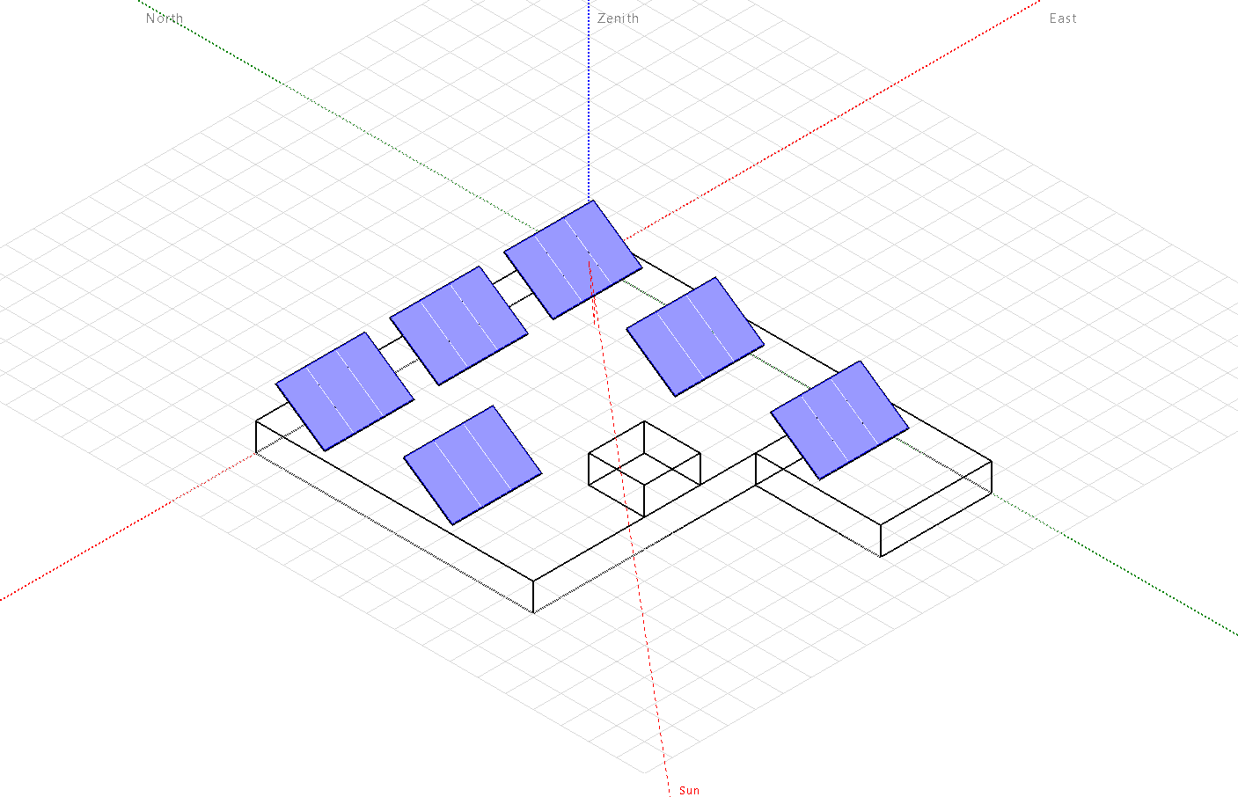
Figure 20. schematic of the first scenario.

After performing the simulation, the system output data are presented in Figure 21, while the annual performance results are illustrated in Plot 6. Additionally, a detailed breakdown of the system losses is provided in Figure 22.
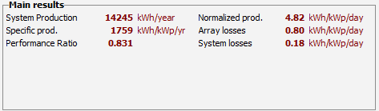
Figure 21. output data of the 1st scenario.
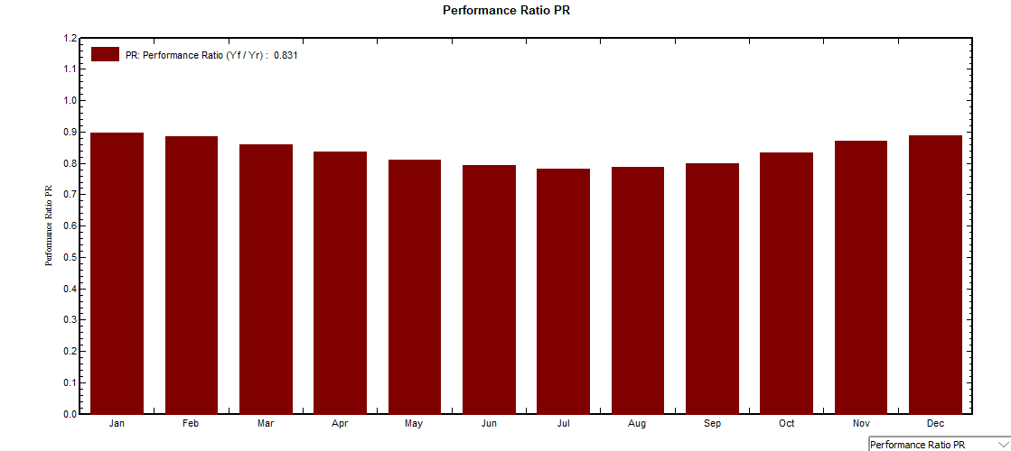
Plot 6. Performance ratio each month.
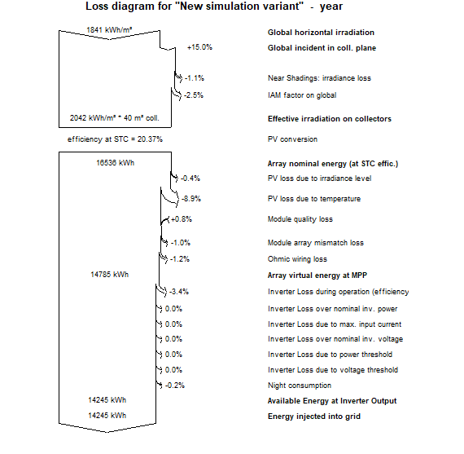
Figure 22. total losses of the system.
Scenario 2)
In this scenario, the system configuration consists of two inverters, each connected to ten photovoltaic modules. The technical specifications of both the panels and inverters are provided in Figure 23, and the arrangement and orientation of the panels are depicted in Figure 24.
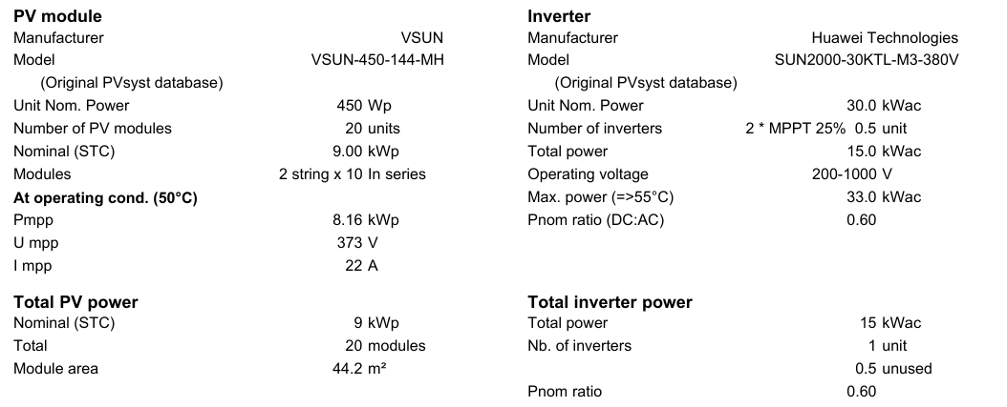
Figure 23. Second scenario’s PV array’s characteristic.
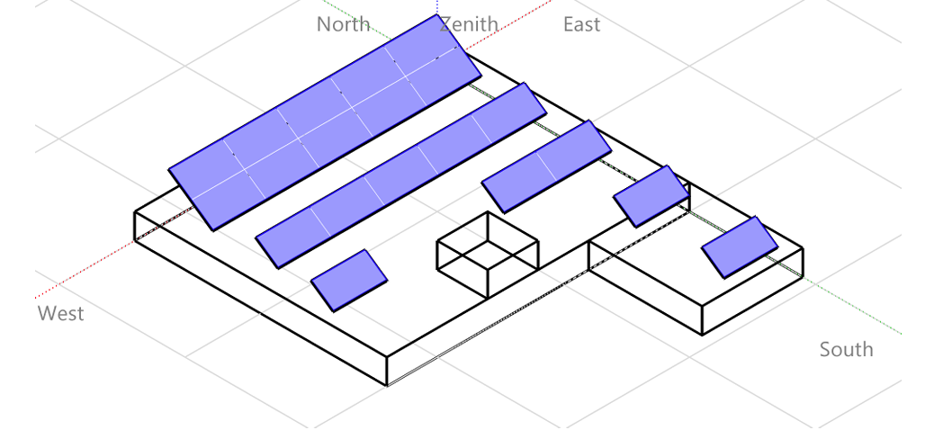
Figure 24. schematic of the second scenario.
Following the simulation, the system output results are presented in Figure 25, while the monthly performance ratio is illustrated in Plot 7. Additionally, a comprehensive summary of the total system losses is provided in Figure 26.
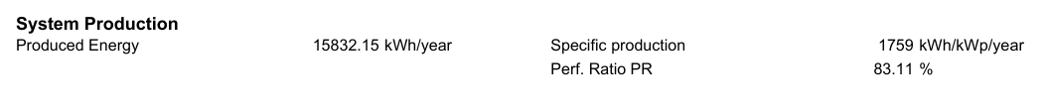
Figure 25. Final results of the 2nd scenario.
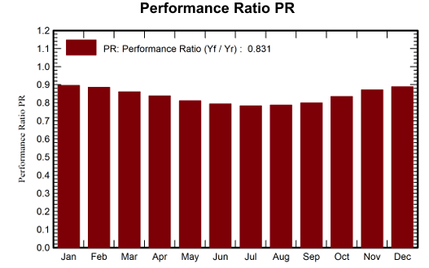
Plot 7. Performance Ratio in each month for the 2nd scenario.
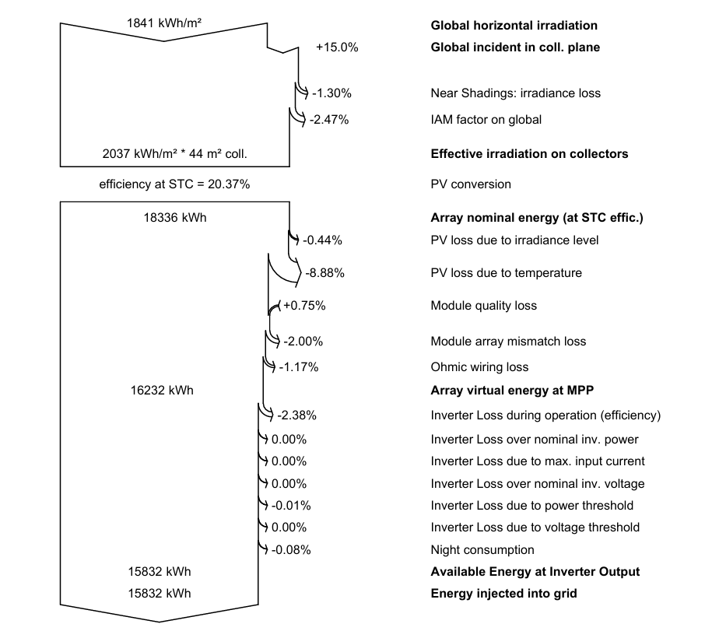
Figure 26. total losses of 2nd scenario.

Validation
By comparing the simulated I–V curves with the reference data provided in the VSUN company catalogue for the photovoltaic panels, a minor deviation is observed. However, this discrepancy is considered acceptable, as it may result from inherent simulation uncertainties or the simplified assumptions and neglected factors within the modeling process.
The comparison of the PVsyst simulation results with the expected performance of real photovoltaic panels indicates that the results are within an acceptable range. For instance, the simulated Performance Ratio (PR) of 83.11% falls within the typical range of 75–85% for rooftop PV systems. Nevertheless, some deviations between simulation and real-world performance may occur due to factors such as variations in actual irradiance and ambient temperature, shading effects, soiling of panels, degradation of module efficiency over time, inaccuracies in system modeling, and simplifications in loss assumptions. These factors can contribute to minor discrepancies between simulated and observed system outputs. [5,6]

Results and discussion
A comparison of the two scenarios indicates that the second scenario achieves a higher power output while maintaining a similar performance ratio. This scenario accommodates a maximum of 20 panels on the rooftop, with a total shading loss of 1.3%, which is considered acceptable within typical system design tolerances.
Photovoltaic (PV) panels serve as the core components of solar energy systems, converting sunlight directly into electricity through the photovoltaic effect. The choice of panel type—whether monocrystalline, polycrystalline, or thin-film—affects efficiency, cost, and space requirements. The energy output of PV panels depends on factors such as solar irradiance, ambient temperature, shading, orientation, and tilt, emphasizing the importance of careful site assessment and optimal installation to maximize performance.
Moreover, long-term performance requires attention to durability, maintenance, and environmental factors. Soiling, dust, snow, and humidity can reduce output, while gradual degradation of panel efficiency over time is inevitable. Proper selection of inverters, mounting structures, and electrical configurations also significantly influences system efficiency. By addressing these considerations, including shading analysis, panel spacing, and performance monitoring, the installed PV system can achieve reliable energy production and maintain high efficiency throughout its operational life.[7]

References
- International Energy Agency (IEA) – “Technology Roadmap: Solar Photovoltaic Energy” (2020).
- U.S. Department of Energy (DOE), Office of Energy Efficiency & Renewable Energy (EERE): “Solar Photovoltaic Technology Basics.”
- https://www.swe-check.com.au/editorials/solar-pv-circuit-protection-guide.php
- PD: 3D Sun-Path
- Siregar et al. (2024) – Comparison of Actual Results and PVsyst Simulation in the Rooftop Solar System
- Freeman et al. (2014) – Validation of Multiple Tools for Flat Plate Photovoltaic Systems
- Jayachandran et al. (2023) – Performance Evaluation and Comparative Study of Three 52-kW Photovoltaic Systems

